April 21, 2016 SLNA Meeting Agenda

The following agenda items were covered. There were no action items or motions.

- Call to Order and Introductions
- Minutes
- Its My Park Day; Easter Egg Hunt and Final Friday April 29.
Maria’s "Final Friday's." For anyone who wants to gather, the first one will be April 29th at 5:30. Kids welcomed (but not required!)
- Welcome Baskets - Carol Gibbs
- Thornton Road Parking
- Zoning.
  - Bannister
  - Clawson
  - Thornton
  - Other
- Code Next Monitor
- Other Announcements
  - 4/23 Town Hall Music and Mobility 12- 2:30 Strange Brew
  - Property Tax Speaker opportunity –Requires special meeting
- Open Forum

Residential Parking Permit and Single Side Parking

Thornton Road

Background
The 2303 Thornton case identified a plan for single side of the street parking on Thornton to improve accessibility. The City staff prefers to implement Residential Parking Permits. We would like to have a formal recommendation from neighbors as soon as possible regarding Plan for Thornton.

Options
Residential Parking Permit Guidelines are available at the following link http://www.austintexas.gov/department/residential-permit-parking. The following excerpts come from that document.

Process Overview

There must be at least a 60% evidence of support for RPP to further the review process. Evidence of support shall be collected using a standardized petition form provided by the City. Residents will have the ability to indicate that they support review, oppose review, or agree with the majority of other responders regarding review for RPP. The process for collection of evidence of support is defined in subsequent sections. Action to move forward will be defined as follows:

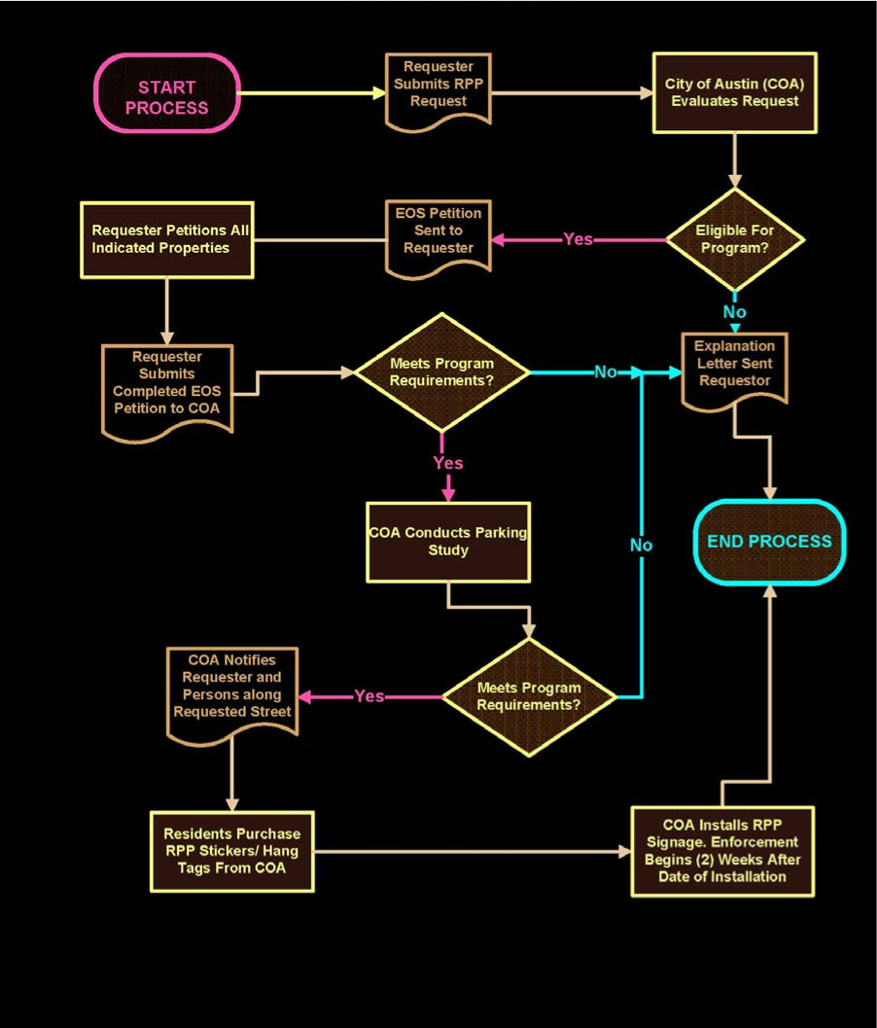

Who can participate? Not really sure…off street parking exists.

Multi-family residential properties built or permitted after 1959 with seven or more units and non-residential land uses are ineligible to participate in the RPP program; however those properties will receive notice of the implementation of RPP along an abutting street segment. The City of Austin, through the building permit process, has required off-street parking be provided by these excluded properties.
From the City perspective it is only the SF properties in green below. But it may be less than that using the second picture.

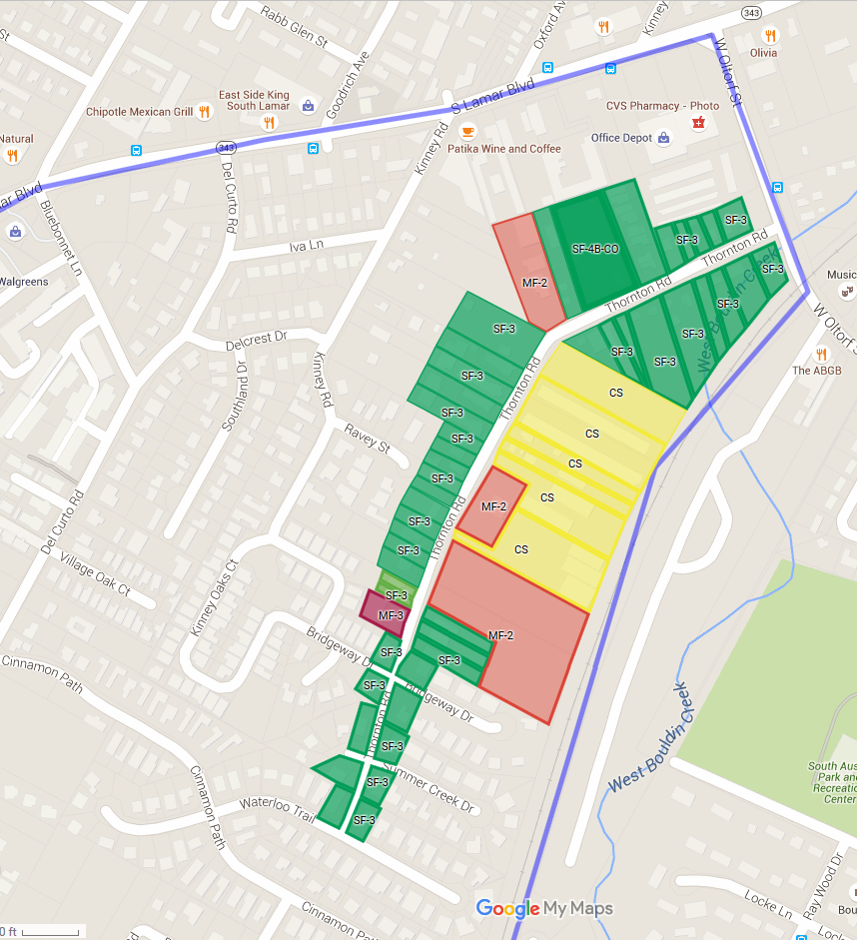

Figure 1
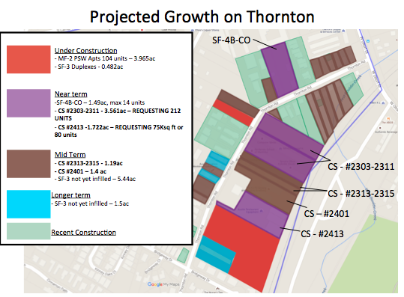
Figure 2

